INFO 6205 Algorithms

Final Project Report

Travelling Salesman Problem Base on Particle Swarm Intelligence

Wenhe Ma

In the final project instructor, I had a deeper understanding of the particle swarm optimization, which is one of the hottest area of artificial intelligence. Per the final project instructor, we should implemented the PSO algorithms as well as solve problems with it. So I divided my project into two parts. In the first part, I implemented the basic functions of PSO in java, and in the second part, I tried to use the PSO algorithms to solve a practical problem, the famous travelling salesman problem.

Part 1

In the first part of my final project, I implemented the basic functions of PSO to simulate the in java. Also, I implemented multi-thread to increase the efficiency of my code with Thread class and Runnable interface. Each of my particle is a thread.

I used Java Swing to visualize my swarm and observed how the flock move under different condition.

The figures below show the final version of my swarm intelligence simulation. The black circle represents the target of the swarm and the colorful circles represent multiple agents in my swarm. As we can see from Figure 1 to Figure 3, particles are converging to the target by adjusting their velocity.

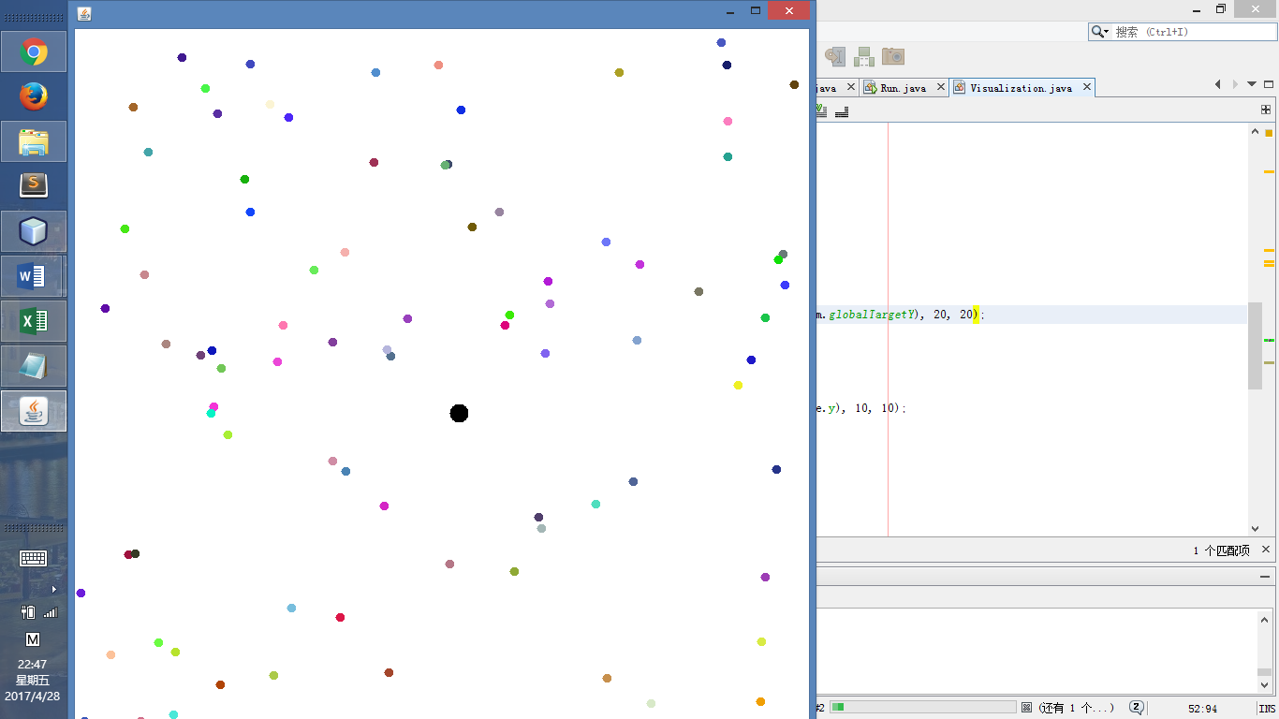

Figure 1.

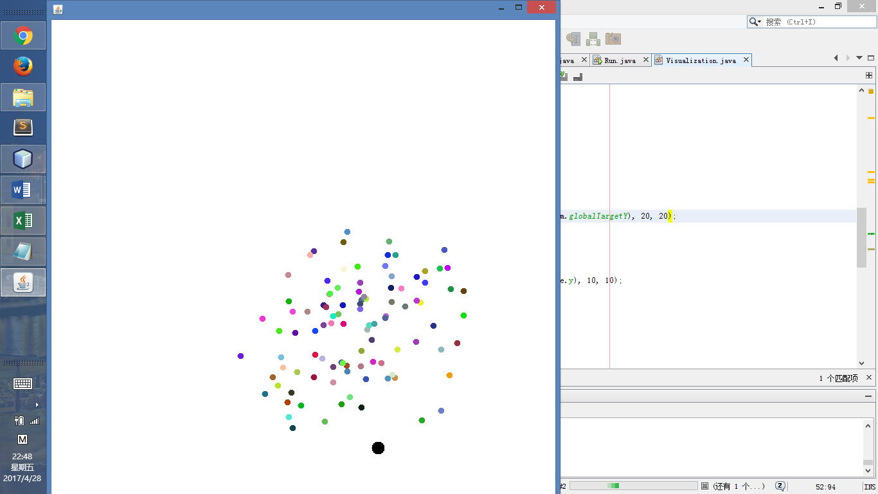

Figure 2.

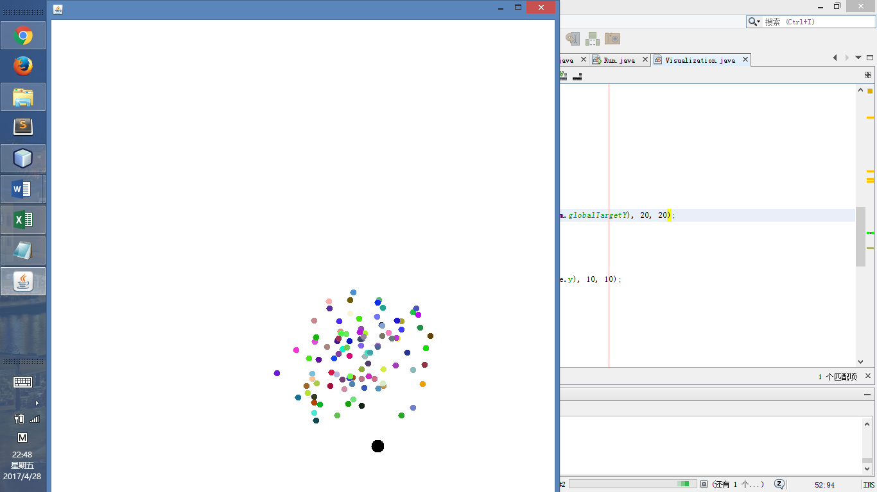

Figure 3.

And the following command line output clearly shows how position and velocity of different particles changes over iterations.

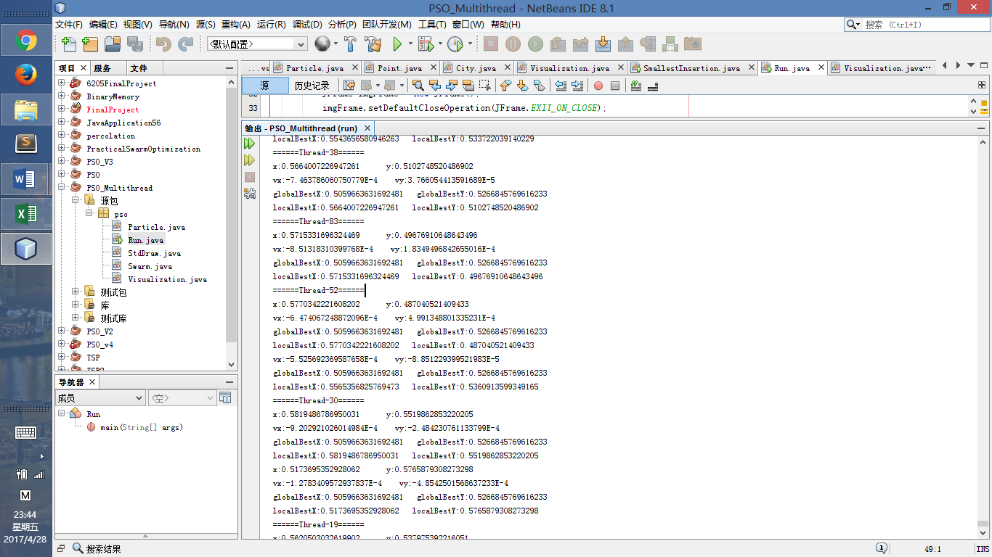

Figure 4

One of the problem that I faced with in this part is to deal with options in the equation and to adjust border of position and velocity to guarantee better visualization.

Another problem is to deal with multithread and debug them. Since this is the very first time that I have ever used this technique, I read about multithread a lot. Another thing is, it is very difficult to debug multithread so I must guarantee a right single thread.

Part 2

For the second part of my final project, I used the algorithms to solve the famous travelling salesman problem. In this particular problem,

The figure below shows an example of my data of city.

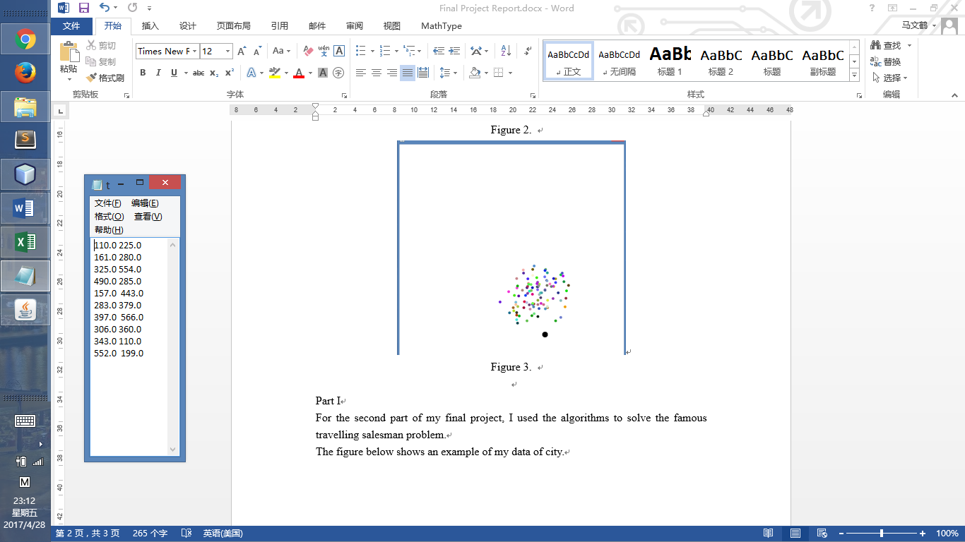

Figure 5. tsp10.txt

In this part, I used both command line and visualization to show my output.

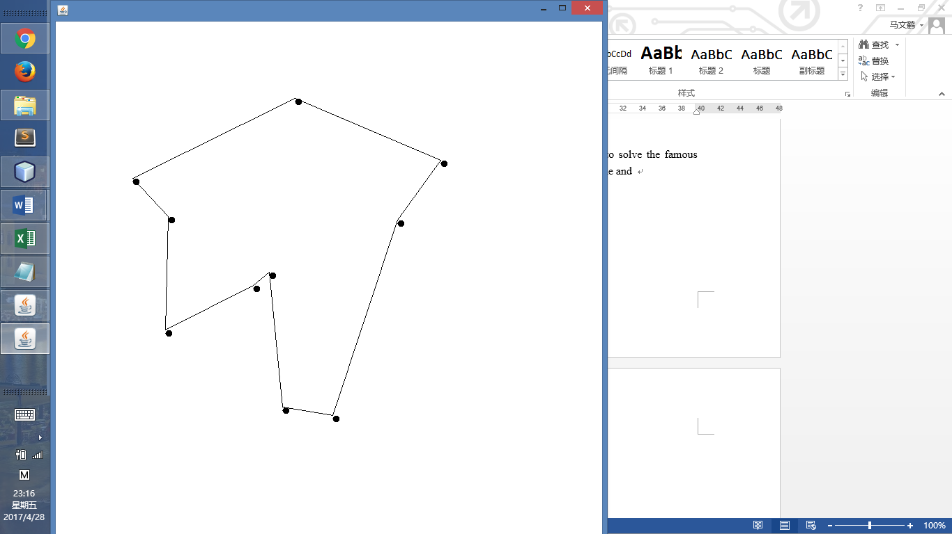

Figure 6.A visual result of tsp10.txt

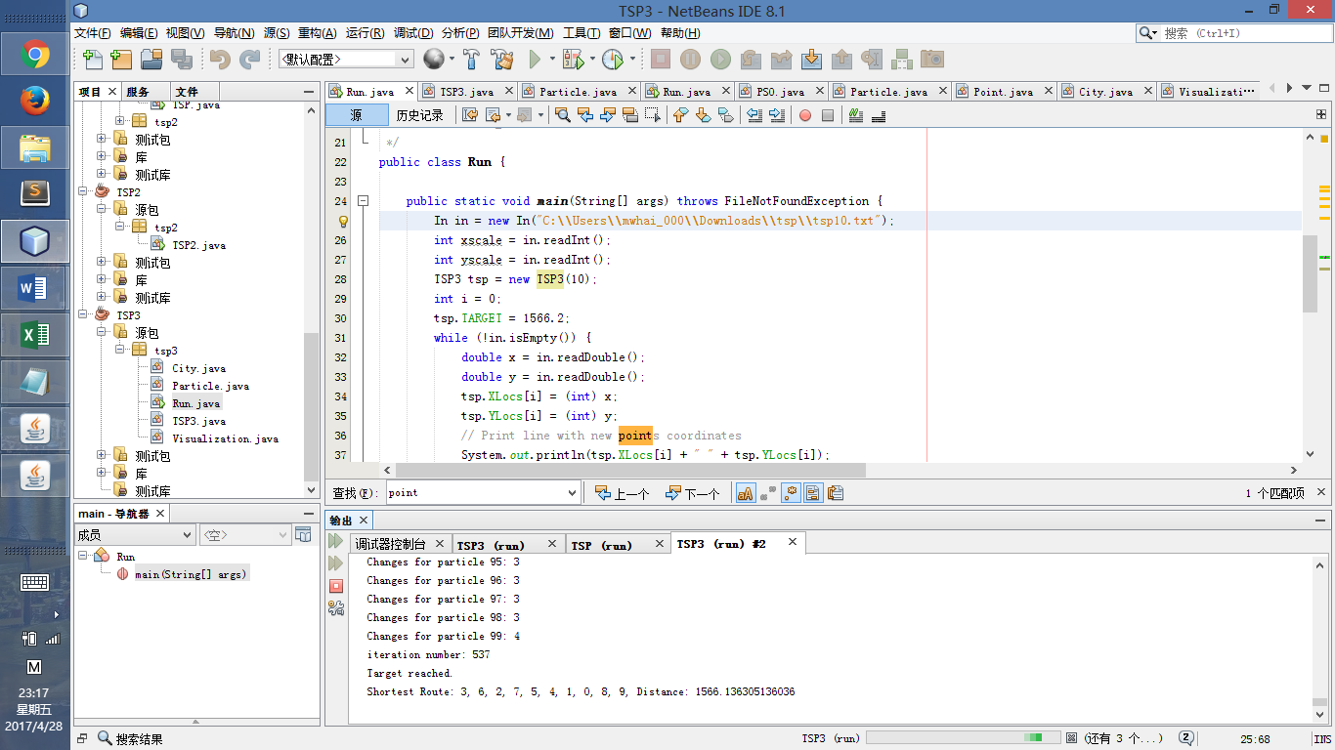

Figure 7.A command line result of tsp10.txt

I also compared my PSO algorithms to and run it under different conditions.

For the 10 city TSP problem mentioned above, it takes my PSO algorithms 10 agents (particles) 411 iterations to reach an acceptable target, which is about 1566 in distance. And if I do more iterate, the algorithms can have better behavior. For example, after 1000 iterations of 10 particles the shortest path found is 1490.76052947333 in length, and after 1000 iterations of 100 particle, the shortest distance reduced to 1446.00110840396.

Moreover, I tried my algorithms on large data. And the results is shown below:

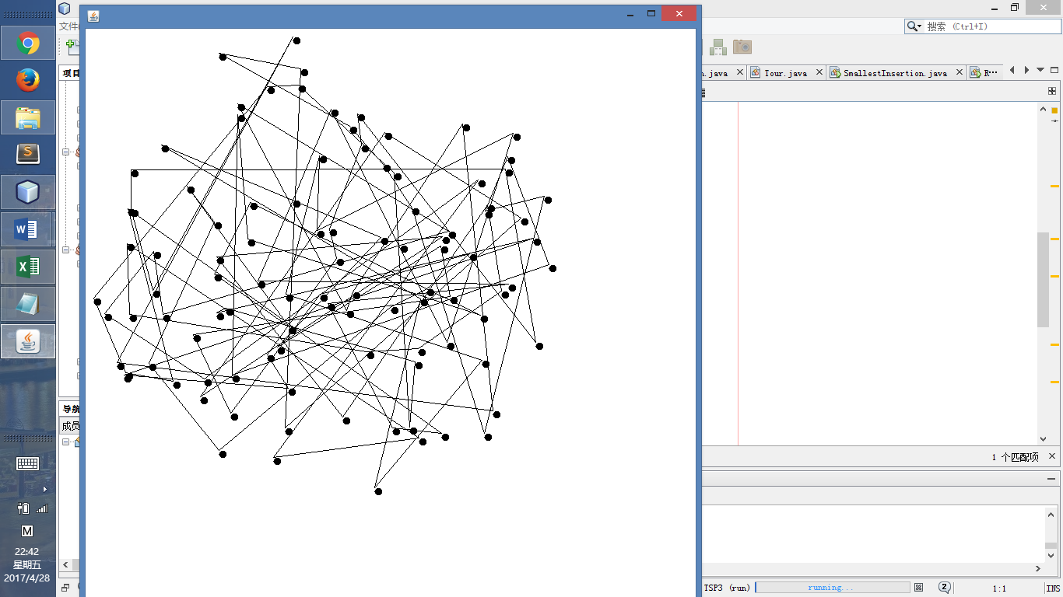

Figure 8. 100 cities, 100 particles after 100 iterations

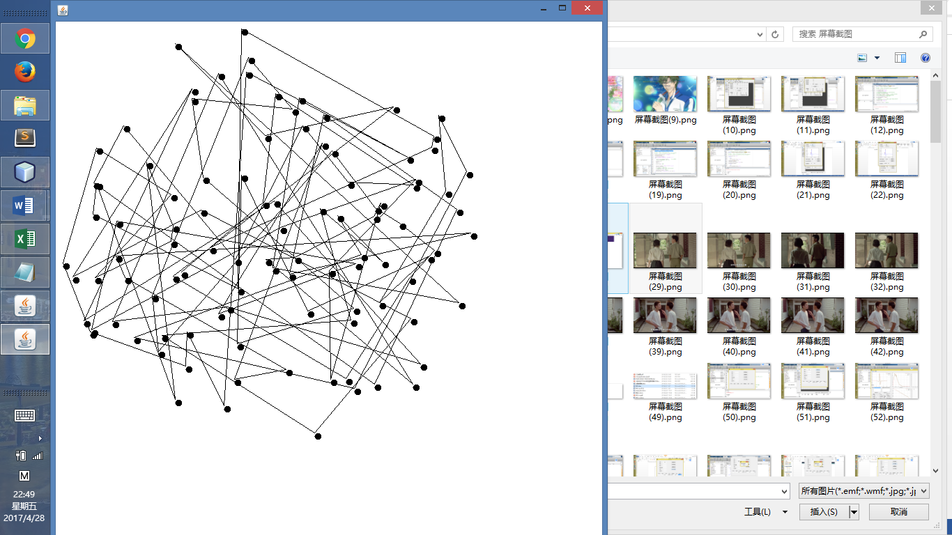

Figure 9. 100 cities, 100 particles after 1000 iterations.